EduMiP Assembly

Included in your EduMiP kit are all of the components necessary to make your BeagleBone balance. Open your kit and inspect the following components. For component name clarification, please refer to the exploded view in the technical document in the product GitHub repository here.
- Drivetrain unit with motors and encoder boards attached (1)
- Wheels (2)
- Robotics Cape (1)
- 2-Pin JST ZH Pigtails (3)
- 4-Pin JST SH Pigtails (3)
- 2-Cell LiPo Battery (1)
- 12v 1A DC Power Supply (1)
- Barrel Jack Plug (1)
- Lower Bulkhead (1)
- M3x10mm Self tapping screws (2)
- M2.6x8mm Self tapping screws (4)
- M2.6x6mm Self tapping screws (6)
- Lower Front Bumper (1)
- Top Skid Right (1)
- Top Skid Left (1)
- Battery Retainer (1)
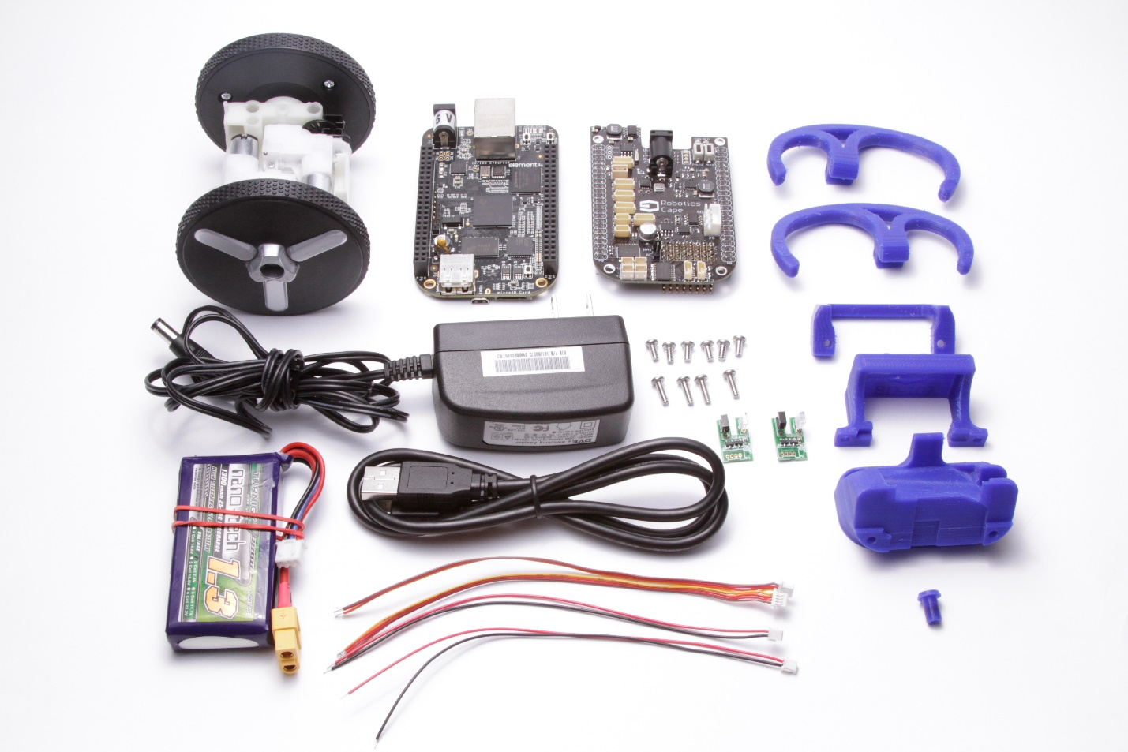
Step 1: Disassemble the powertrain unit by removing the 8 screws holding the gearboxes in.
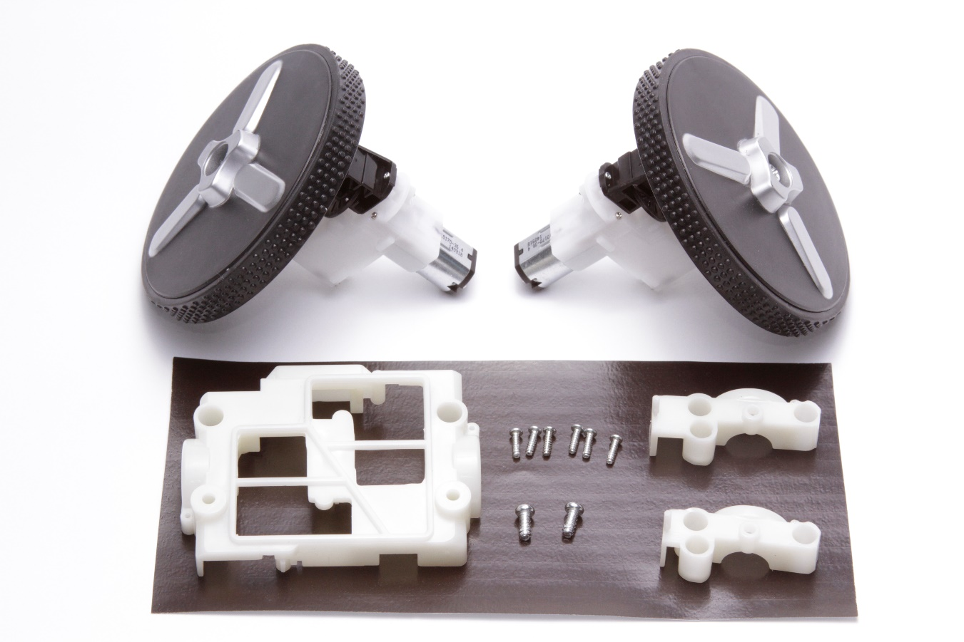
Step 2: The motor leads come pre-tinned and cut to length. Solder to the motor terminals such that they lead the motor towards the wheel axis. Double check that the red wires go to the positive(+) terminals of the motors.
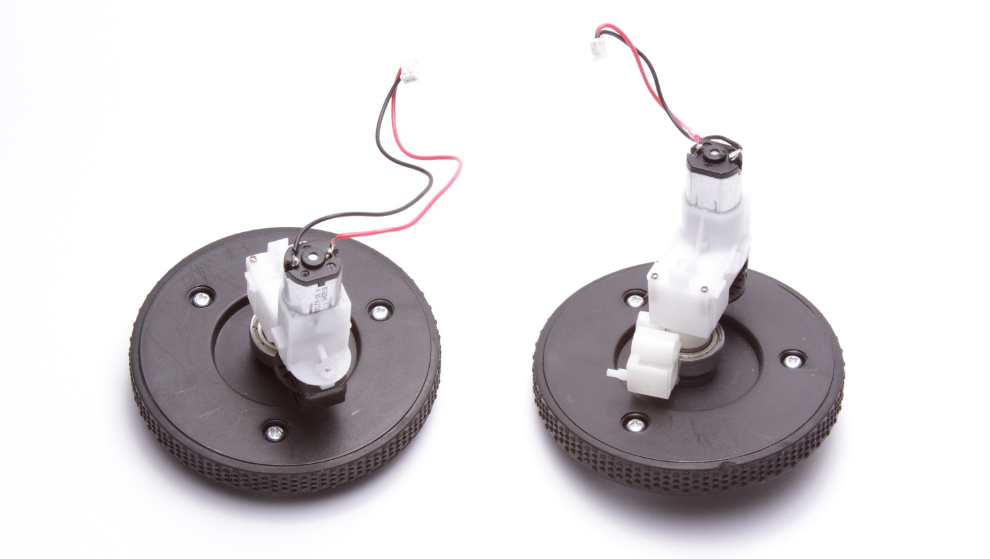
Step 3: Put the powertrain unit back together with the motor wires and press the encoder boards in to match the orientation in the following picture.
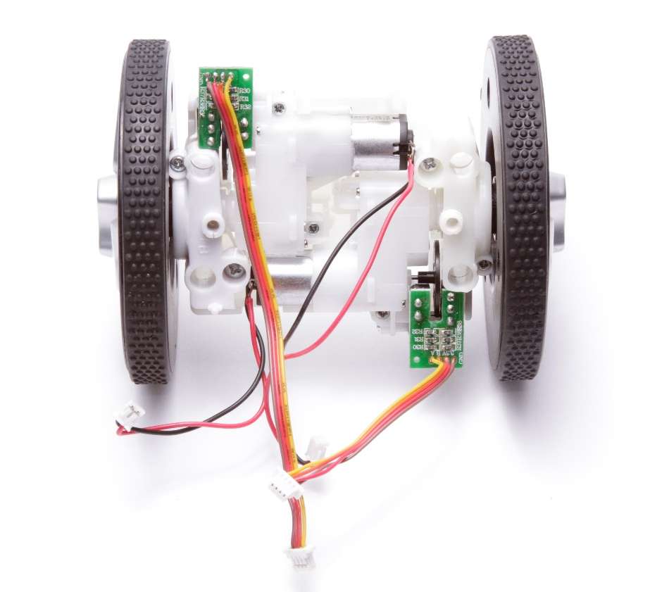
Step 4: Use two of the M2.6x8mm screws to mount the Lower Bulkhead to the top of the powertrain unit. Be careful not to pinch any of the wires before tightening the screws fully. This is a good time to check that the wheels and encoders can move freely without obstructions.
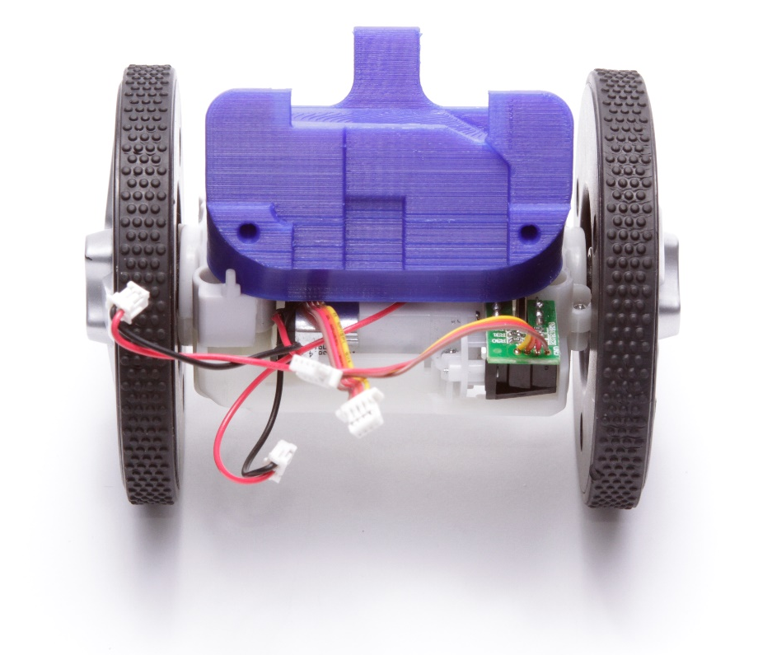
Step 5: Now install your BeagleBone Black onto the Lower Bulkhead with two M2.6x6mm screws. Also insert the plastic barrel jack plug cover into the BeagleBone’s 5V DC input Jack.
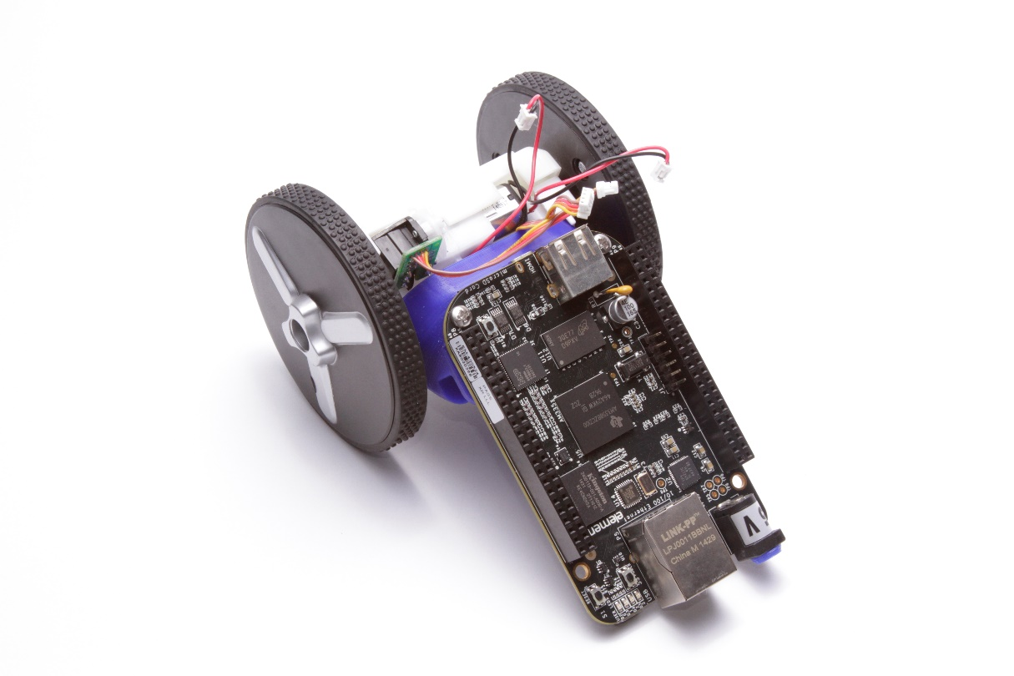
Step 6: Install the Robotics Cape onto the BeagleBone Black paying careful attention not to bend any pins and make sure both connectors are completely inserted. Now install the Top Left Skid using only one M2.6x6mm screw from the front side of the cape as shown below. We will install the second screw later.
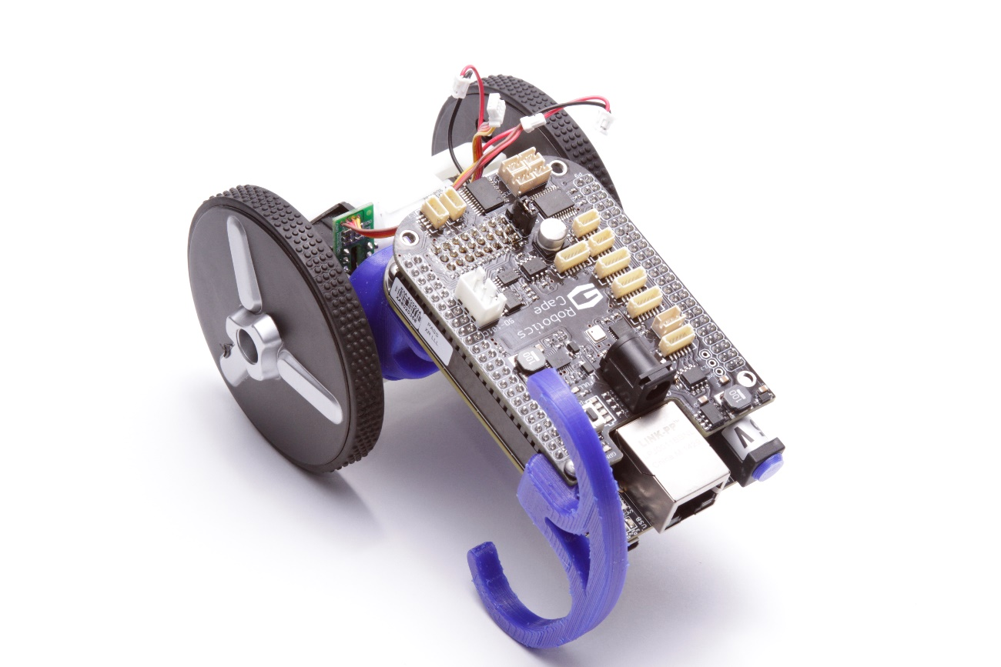
Step 7: Slide the battery and retaining clip into place behind the BeagleBone Black and secure with one M2.6x8mm screw through the Battery Retaining Clip into the Top Left Skid hold that you left open in the last step. Now install the Top Skid Right in the same manner with a ¼” screw from the front of the cape followed by a M2.6x8mm screw from the back side.
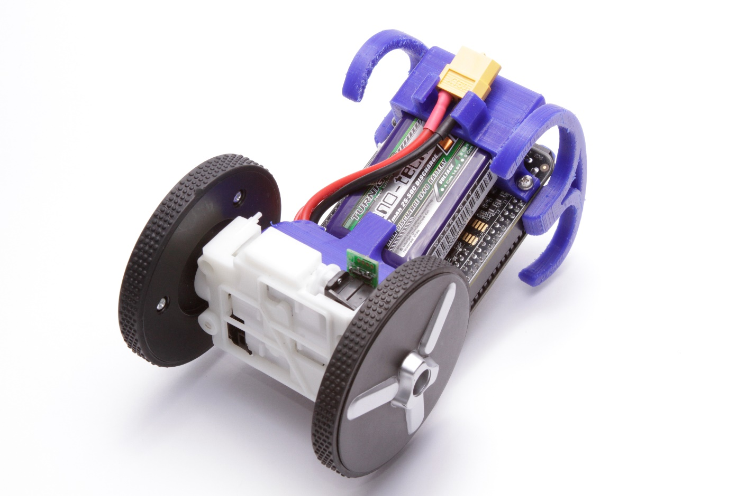

Step 8: Plug in the Robotics Cape and connectors. Leave the battery unplugged to prevent the BeagleBone from turning on. Connect the wires as follows:
- Encoder lead from the front (cape side) of the MiP to encoder header E3.
- Encoder lead from the back (battery side) of the MiP to encoder header E2.
- Motor lead from the front (cape side) motor to motor header M2.
- Motor lead from the back (battery side) motor to motor header M3.
Please note the picture below is outdated and shows the motor leads plugged into the wrong headers. The encoders are pictured correctly.

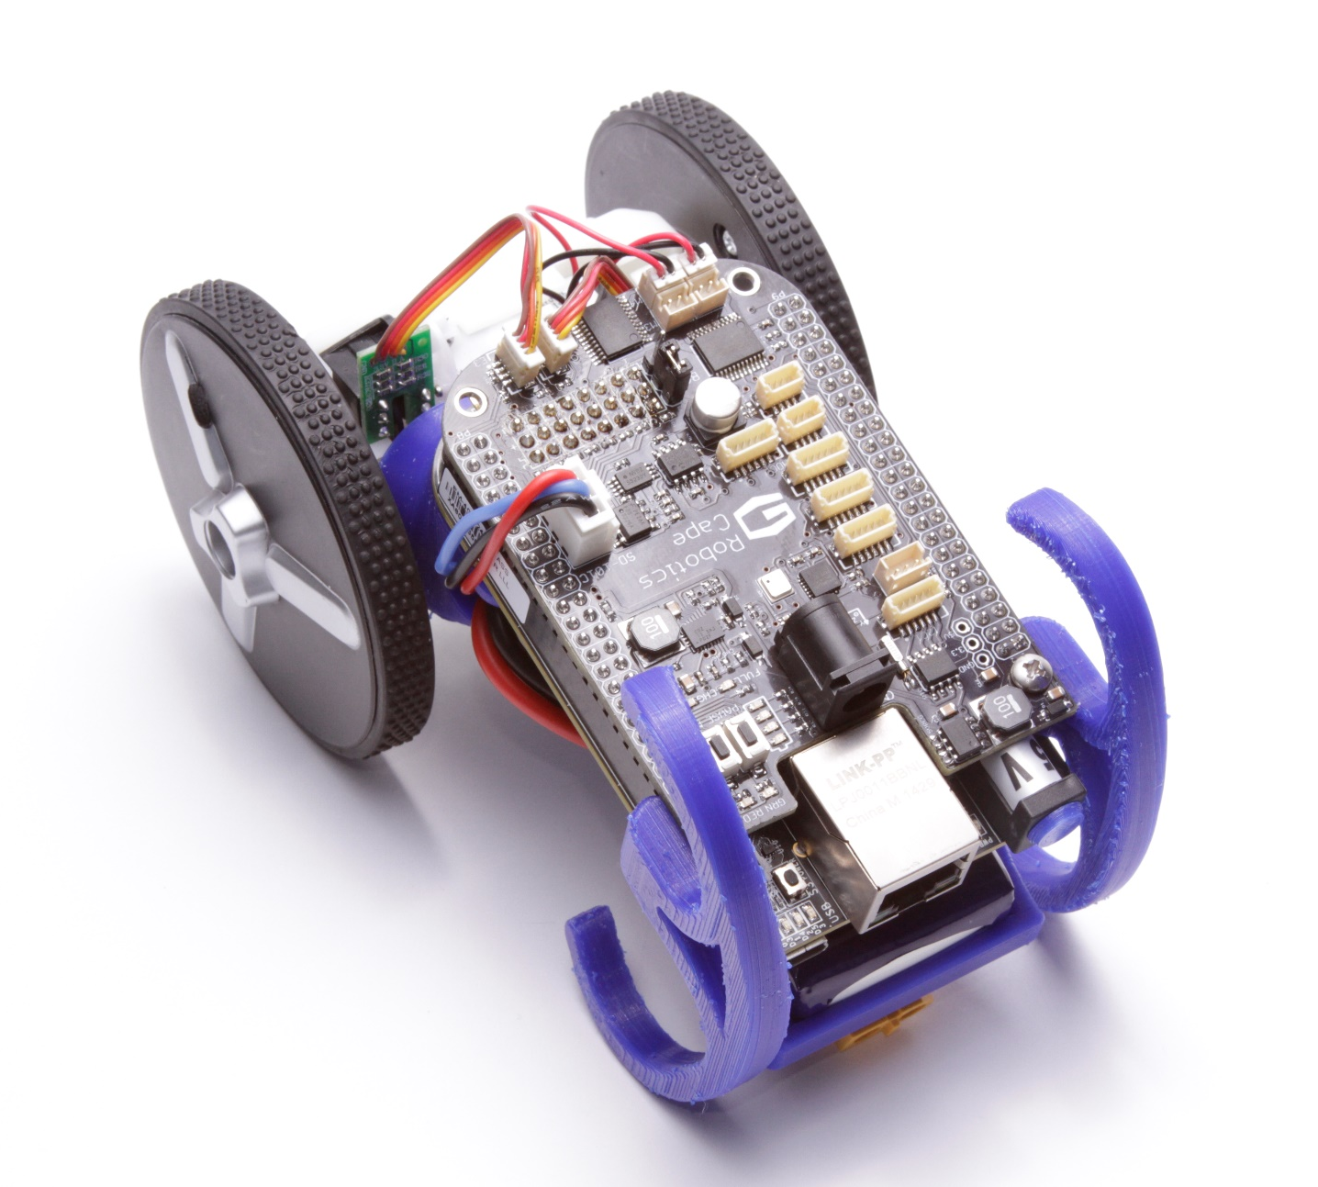

Step 9: Lastly, screw in the Lower Bumper with the remaining 2 M2.6x6mm screws as shown. You can now plug in the battery and charger to let the battery charge.
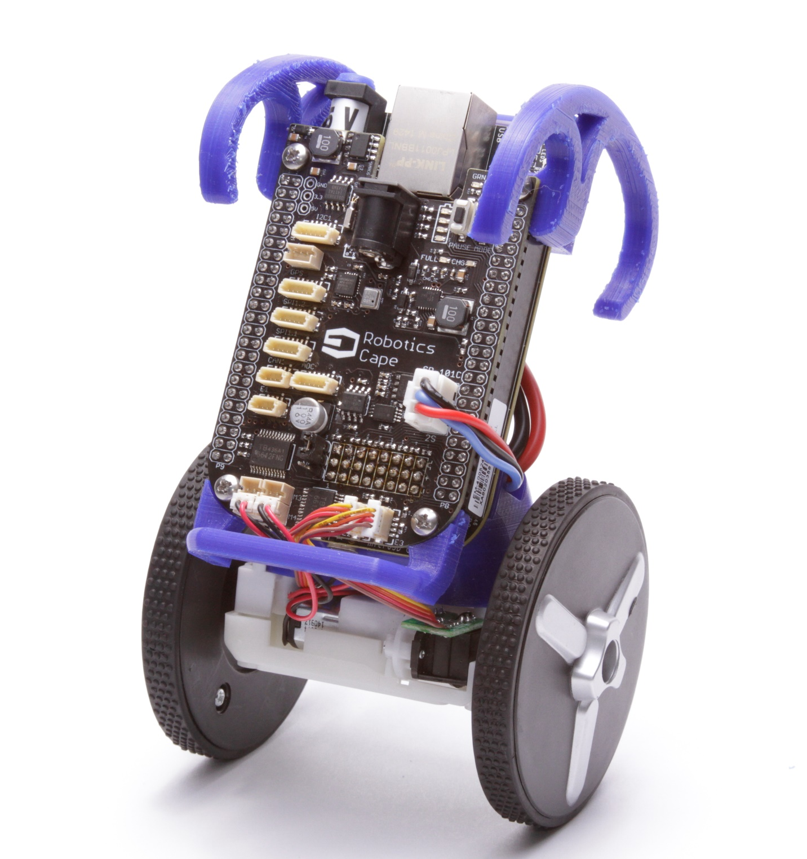
The Robotics Cape installer package comes with an example program to demonstrate EduMiP functionality. Please follow the instructions at http://strawsondesign.com/#!manual-install to install the software and set the ‘balance’ example to run automatically on boot.

